Network Configuration

14.1 Introduction
Having access to the network is a key feature of most Linux systems. Users want to surf the net, send and receive email and transfer files with other users.
Typically the programs that perform these functions, such as web browsers and email clients, are reasonably easy to use. However, they all rely on an important feature: the ability of your computer to communicate with another computer. To have this communication, you need to know how to configure your system's network.

14.2 Basic Network Terminology

Host | A host is a computer. Many people automatically think of a desktop computer or laptop when they hear the term computer. In reality, many other devices, such as cell phones, digital music players and many modern televisions, are also computers. In networking terms, a host is any device that communicates via a network with another device.
Network | A network is a collection of two or more hosts (computers) that are able to communicate with each other. This communication can be via a wired connection or wireless.
Internet | The Internet is an example of a network. It consists of a publicly accessible network that connects millions of hosts throughout the world. Many people use the Internet to surf web pages and exchange emails, but the Internet has many additional capabilities besides these activities.
Wi-Fi | The term Wi-Fi refers to wireless networks.
Server | A host that provides a service to another host or client is called a server. For example, a web server stores, processes and delivers web pages. An email server receives incoming mail and delivers outgoing mail.
Service | A feature provided by a host is a service. An example of a service would be when a host provides web pages to another host.
Client | A client is a host that is accessing a server. When you are working on a computer surfing the Internet, you are considered to be on a client host.
Router | Also called a gateway, a router is a machine that connects hosts from one network to another network. For example, if you work in an office environment, the computers within the company can all communicate via the local network created by the administrators. To access the Internet, the computers would have to communicate with a router that would be used to forward network communications to the Internet. Typically when you communicate on a large network (like the Internet), several routers are used before your communication reaches its final destination.

14.3 Networking Features Terminology
In addition to the networking terms discussed in the last section, there are some additional terms with which you should be familiar. These terms focus more on the different types of networking services that are commonly used, as well as some of the techniques that are used to communicate between machines.
Packet | A network packet is used to send network communication between hosts. By breaking down communication into smaller chunks (packets), the data delivery method is much more efficient.
IP Address | An Internet Protocol (IP) address is a unique number assigned to a host on a network. Hosts use these numbers to address network communication.
Mask | Also called a netmask, subnet mask or mask, a network mask is a number system that can be used to define which IP addresses are considered to be within a single network. Because of how routers perform their functions, networks have to be clearly defined.
Hostname | Each host on a network could have its own hostname because names are more natural for humans to remember than numbers, making it easier for us to address network packets to another host. Hostnames are translated into IP addresses before the network packet is sent on the network.
URL | A Uniform Resource Locator (URL), also commonly called a web address, is used to locate a resource, like a web page, on the internet. It’s what you type into your web browser to access a web page. For example, http://www.netdevgroup.com. It includes the protocol http:// and the hostname www.netdevgroup.com.
DHCP | Hosts can be assigned hostnames, IP addresses and other network-related information by a DHCP (Dynamic Host Configuration Protocol) server. In the world of computers, a protocol is a well-defined set of rules. DHCP defines how network information is assigned to client hosts, and the DHCP server is the machine that provides this information.
DNS | As mentioned previously, hostnames are translated into IP addresses, prior to the network packet being sent on the network. So your host needs to know the IP address of all of the other hosts with which you are communicating. When working on a large network (like the Internet), this can pose a challenge as there are so many hosts. A Domain Name System (DNS) provides the service of translating domain names into IP addresses.
Ethernet | In a wired network environment, Ethernet is the most common way to physically connect the hosts into a network. Ethernet cables are connected to network cards that support Ethernet connections. Ethernet cables and devices (such as routers) are specifically designed to support different communication speeds, the lowest being 10 Mbps (10 Megabits per second) and the highest being 100 Gbps (100 gigabits per second). The most common speeds are 100 Mbps and 1 Gbps.
TCP/IP | The Transmission Control Protocol/Internet Protocol (TCP/IP) is a fancy name for a collection of protocols (remember, protocol = set of rules) that are used to define how network communication should take place between hosts. While it isn't the only collection of protocols used to define network communication, it is the most often utilized one. As an example, TCP/IP includes the definition of how IP addresses and network masks work.

14.4 IP Addresses
There are, in fact, two different types of IP addresses: IPv4 and IPv6. To understand why there are two different types, you need to understand a brief bit of IP addressing history.
For many years, the IP addressing technique that was used by all computers was IPv4. In an IPv4 address, a total of four 8-bit numbers are used to define the address. This is considered a 32-bit address (4 x 8 = 32). For example:
192.168.10.120.
IPv6 was officially created in 1998. In an IPv6 network the addresses are much larger, 128-bit addresses that look like this:
2001:0db8:85a3:0042:1000:8a2e:0370:7334

14.5 Configuring Network Devices
When you are configuring network devices, there are two initial questions that you need to ask:
- Wired or wireless? Configuring a wireless device is slightly different to configuring a wired device because of some of the additional features typically found on wireless devices (such as security).
- DHCP or static address? Recall that a DHCP server provides network information, such as your IP address and subnet mask. If you don't make use of a DHCP server, then you will need to manually provide this information to your host, which is called using a static IP address. ‌

14.5.1 Network Configuration Files
Name resolution on a Linux host is accomplished by 3 critical files: the /etc/hosts, /etc/resolv.conf and /etc/nsswitch.conf files. Together, they describe the location of name service information, the order in which to check resources, and where to go for that information.

Files | Explanation
/etc/hosts | This file contains a table of hostnames to IP addresses. It can be used to supplement a DNS server.  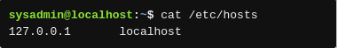
/etc/resolv.conf | This file contains the IP addresses of the name servers the system should consult in any attempt to resolve names to IP addresses. These servers are often DNS servers. It also can contain additional keywords and values that can affect the resolution process.  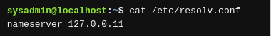
/etc/nsswitch.conf | This file can be used to modify where hostname lookups occur. It contains a particular entry that describes in what order name resolution sources are consulted.  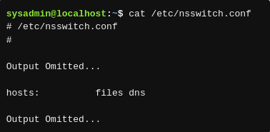  The /etc/hosts file is searched first, the DNS server second:  hosts: files dns  The DNS server would be searched first, local files second:  hosts: dns files

14.6 Network Tools
There are several commands that you can use to view network information. These tools can also be useful when you are troubleshooting network issues.

14.6.1 The ifconfig Command
The ifconfig command stands for interface configuration and is used to display network configuration information.
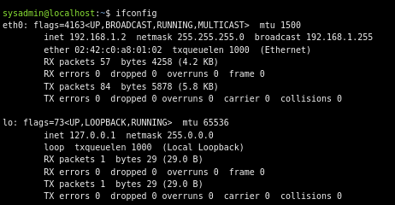

14.6.2 The ip Command

The ip command differs from ifconfig in several important manners, chiefly that through its increased functionality and set of options, it can almost be a one-stop shop for configuration and control of a system’s networking. The format for the ip command is as follows:
ip [OPTIONS] OBJECT COMMAND
The ip command branches out to do some of the work of several other legacy commands such as route and arp.
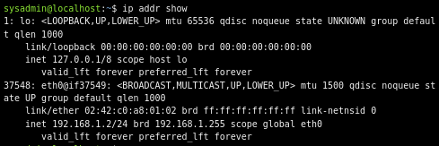

14.6.3 The route Command
To view a table that describes where network packages are sent, use the route command:
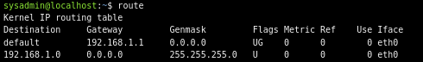

14.6.4 The ping Command
The ping command can be used to determine if another machine is reachable. If the ping command can send a network package to another machine and receive a response, then you should be able to connect to that machine.
By default, the ping command continues sending packages endlessly. To limit how many pings to send, use the -c option followed by a number indicating how many iterations you desire. The following examples show ping being limited to 4 iterations.
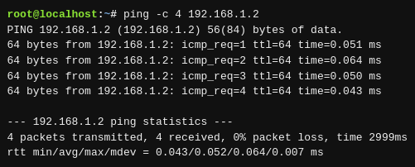

14.6.5 The netstat Command
The netstat command is a powerful tool that provides a large amount of network information. It can be used to display information about network connections as well as display the routing table similar to the route command.
For example, to display statistics regarding network traffic, use the -i option to the netstat command:
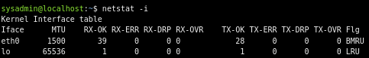

To use the netstat command to display routing information, use the -r option:
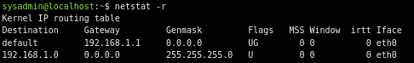

The netstat command is also commonly used to display open ports. A port is a unique number that is associated with a service provided by a host. If the port is open, then the service is available for other hosts.
For example, you can log into a host from another host using a service called SSH. The SSH service is assigned port #22. So, if port #22 is open, then the service is available to other hosts.
To see a list of all currently open ports, use the following command:
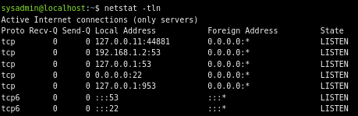

In the previous example, -t stands for TCP (recall this protocol from earlier in this chapter), -l stands for listening (which ports are listening) and -n stands for show numbers, not names.

14.6.6 The ss Command
The ss command is designed to show socket statistics and supports all the major packet and socket types. Meant to be a replacement for and to be similar in function to the netstat command, it also shows a lot more information and has more features.
The main reason a user would use the ss command is to view what connections are currently established between their local machine and remote machines, statistics about those connections, etc.
Similar to the netstat command, you can get a great deal of useful information from the ss command just by itself as shown in the example below.
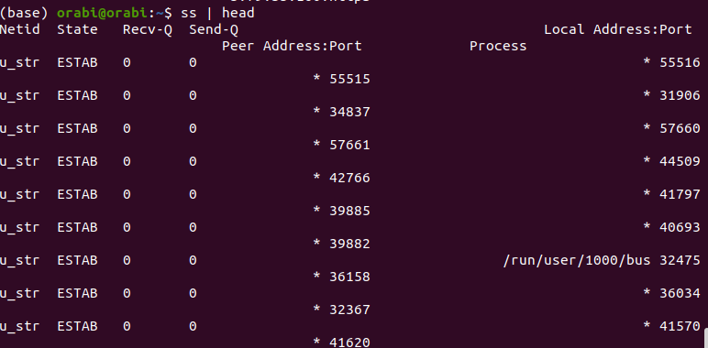

The output is very similar to the output of the netstat command with no options. The columns above are:
Netid | The socket type and transport protocol
State | Connected or Unconnected, depending on protocol
Recv-Q | Amount of data queued up for being processed having been received
Send-Q | Amount of data queued up for being sent to another host
Local Address | The address and port of the local host’s portion of the connection
Peer Address | The address and port of the remote host’s portion of the connection

the use of the -s option, which displays mostly the types of sockets, statistics about their existence and numbers of actual packets sent and received via each socket type
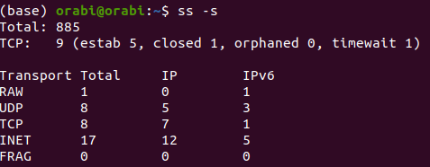

14.6.7 The dig Command
There may be times when you need to test the functionality of the DNS server that your host is using. One way of doing this is to use the dig command, which performs queries on the DNS server to determine if the information needed is available on the server.
In the following example, the dig command is used to determine the IP address of the example.com host:
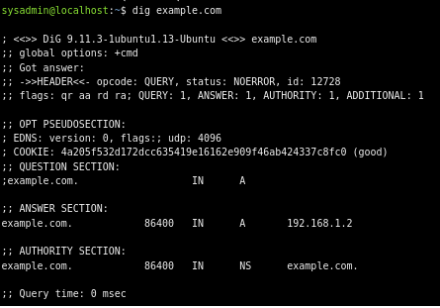

Note that the response included the IP address of 192.168.1.2, meaning that the DNS server has the IP address to hostname translation information in its database.
If the DNS server doesn't have the requested information, it is configured to ask other DNS servers. If none of them have the requested information, an error message displays:
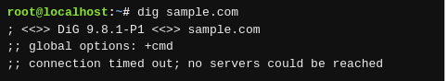

14.6.8 The host Command
In its simplest form, the host command works with DNS to associate a hostname with an IP address. As used in a previous example, example.com is associated with the IP address of 192.168.1.2:
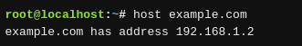

The host command can also be used in reverse if an IP address is known, but the domain name is not.
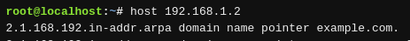

14.6.9 The ssh Command
The ssh command allows you to connect to another machine across the network, log in and then perform tasks on the remote machine.
If you only provide a machine name or IP address to log into, the ssh command assumes you want to log in using the same username that you are currently logged in as. To use a different username, use the syntax:
username@hostname
